

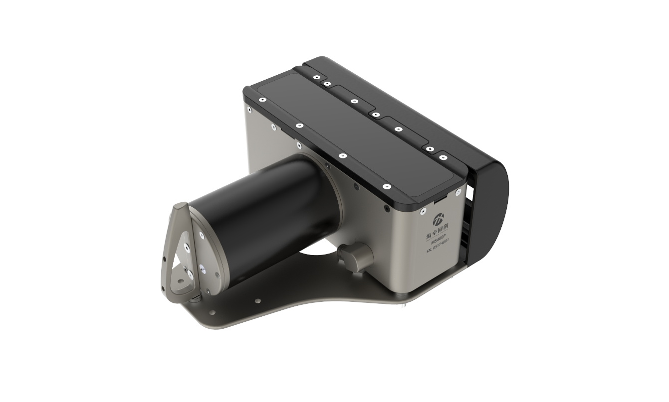

**Hydro-Tech MS400P**

**Multibeam Echo Sounder**

**User Manual**

**Beijing Hydro-Tech Marine Technology Co., Ltd.**

**V1.3 Feb. 2022**

**Copyright**

This manual including the products and software mentioned in it belong to copyright 2022 of Beijing Hydro-Tech Marine Technology Co., Ltd. Without the written permission of Hydro-Tech, the manual and its relevant parts shall not be copied or reprinted in any pattern.

**Customer Supports**

Welcome to contact us at any time. We would feedback in time and provide good service to you. Below is the contact information.

Beijing Hydro-Tech Marine Technology Co., Ltd.

Address: 1F Building 5, No. 33 Jingsheng South 2nd Street, TongzhouDist, Beijing

Postcode: 101102

Tel: 010-57136778

Fax: 010-67870776

Website: [www.hydro-tech.cn](http://www.hydro-tech.cn/)

**Table of Contents**

1. Introduction 1

1.1. Product Introduction 1

1.2. How to Use This Manual 2

2. System Specifications 3

2.1. System Specifications 3

2.2. Physical Specifications 3

2.3. Electrical Specifications 4

2.4. Compatiable Software 4

2.5. Auxiliary Measuring Devices 4

3. Safety 5

3.1. Equipment Safety 5

3.2. Maintenance 5

4. Acoustic Transducer Operation 6

5. Sonar Interface Module Operation 7

5.1. Sonar Interface Module Introduction 7

5.2. Sonar Interface Module Connecters and Indicators 8

5.2.1. Front Panel 8

5.2.2. Back Panel 8

6. System Installation and Configuration 11

6.1. Underwater Parts Installation 13

6.1.1. Underwater Transducer Installation 14

6.1.2. Underwater Installation Precautions 14

6.2. Sonar Interface Module Installation 15

6.2.1. Sonar Interface Module Introduction 15

6.2.1. Sonar Interface Module Installation 19

7. How to set up RTK? 20

7.1. How to use NTRIPClient 23

7.2. COM Port Setting 23

7.3. NTRIP Setting 24

7.4. Check the Internal GPS Status 26

Appendix 1 Underwater Transducer Drawing 27

Appendix 2 Transducer & IMU Center Drawing 28

Appendix 3 Sonar Interface Module (Deck Unit) Drawing 29

Appendix 4 Wet Cable Definition 30

# Introduction

## Product Introduction

MS400P is new generation of multi beam echo sounder that fully reflects the developing trend of the industry. It has advanced concepts and excellent performance, such as small and compact, light weight (8.3kg only), low power consumption (Less than 40W). Its installation is quick and convenient.

MS400P (Elf) has changed traditional hydrographic surveying concept with the powerful function and great accuracy, which fully meets the IHO S44 Special Order. Ms400p (Elf) is designed as easy operation. Even only one person can work freely!

MS400P multibeam echo sounder mainly consists of underwater acoustic transducer and sonar interface module. Below is the system diagram shown in Figure 1.1.

Figure 1.1 System Diagram

It works together with system software, including display and control software named “HydroQuest” and navigation & data acquisition software named “HydroNavi”.

## How to Use This Manual

This manual introduces main technical specification, system framework, functions, installation, operation and safety precautions of MS400P multi beam echo sounder system. It is recommended that users had better read this manual carefully before installing or operating the equipment to avoid unnecessary injury to equipment and personnel.

1. For the users who use MS400P for the first time, please read this manual Part 3. Safety to prevent any damage to equipment or injury to personnel during wrong operation;



1. For the users who use MS400P for the first time, please refer to Part 6. System Installation and Configuration instructions. Furthermore, Appendix 1 and Appendix 2 show the product mechanical drawings and related installation mount &other components.
2. If you have known or used MS400P multibeam echo sounder before, you can directly read the manual of Hydro-Quest to learn how to display and control MS400P.

# System Specifications

## System Specifications

|  |  |
| --- | --- |
| Working Frequency  Depth Resolution | 400kHz  0.75cm |
| No. of Beams  Working Modes | 512  Equiangular or Equidistance |
| Cross Track Beam Width  Along Track Beam Width | 1°  2° |
| Max. Ping Rate  Signal Type | 60kHz  CW or Chirp |
| Swath Sector  Pulse Width | 143°  15μs ~ 8ms |
| Sounding Range  Max. Working Depth | 0.2~150m  50m |

|  |  |
| --- | --- |
| Near Field Focus  Water Column Image | Yes  Yes |
| Realtime Roll Stabilization  Attitude Accuracy (GNSS available) | Yes  0.1°(2m baseline) |

|  |  |
| --- | --- |
| Horizontal Position Accuracy  Heave Accuracy | 1.5m (Single) /2cm+2ppm (RTK)  5cm or5%range |
| Auxiliary Positioning | CORS Network |

## Physical Specifications

|  |  |
| --- | --- |
| Receiving Transducer Size | 288 x 240 x 120mm |
| Transducer Weight | 8.3kg | |
| Sonar Interface Module Size | 200mm×145mm×75mm | |
| Sonar Interface Module Weight | 2Kg | |
| Working Temperature | -2° ~ 40℃ | |
| Storage Temperature | -20℃ ~ 55℃ | |

## Electrical Specifications

|  |  |
| --- | --- |
| Power Supply | DC10V-32V  AC110V-240V |
| Power Consumption | 60W (Standard)  40W (Low Consumption Mode) |
| Data Interface Port | Ethernet |
| Synchronization Output | 5V TTL |
| Auxiliary Device Port | RS232 |
| Deck Cable Length | 8m or Customnized |

## Compatiable Software

* + - HydroQuest: Display and Control Software;
    - HydroNavi: Navigation and Data Collection Software;
    - Compatible with Hypack data collection software and Hypack & Caris post processing software.

## Auxiliary Measuring Devices

* + - Sound Velocity Sensor: Standard built-in SVS1500
    - Sound Velocity Profiler: Optional for SVP1500
    - INS: Optional for external IMU
    - GNSS: Standard internal NovAtel GNSS, or optional for external GNSS

# Safety



In order to ensures the personal and equipment safety during MS400P operation, please read the following details before operation.

## Equipment Safety

1. During transportation, please pack the transport box properly and avoid any possible damage of vibration;
2. Check whether the transporting carton is damaged before unpacking
3. Check whether each part of the system is damaged before installation;
4. Main unit or transducer and other accessories shall not be dropped down;
5. It is forbidden to plug or unplug any connecting cable during equipment working operation;
6. All plug-in or unplug cables of sonar interface module shall not be exposed to rain or water;
7. The sonar interface module shall not be exposed to rain or water to prevent any damage to internal electrical components;
8. When underwater transducer is not put into water, the whole sounding system shall not be powered on for testing or any other operation;
9. It is forbidden to place the underwater transducer directly downward to the ground without protection, especially it is forbidden to scratch the surface of transducer part with hard or sharp objects;
10. All cables of the system shall not be folded, pressed, squeezed, pulled, cut or other operations that may cause physical injury;
11. Not exceed the operating and storage temperature limits;

## Maintenance

When using or storing acoustic transducers, please adapt the following steps to protect it for better maintenance:

1. Cleaning: clean with mild and clean fresh water, and soft brush the outside if needed.
2. Wash the underwater transducer with fresh water after operation each time;
3. It is forbidden to use any antifouling paint to coat the acoustic transducer;
4. It is forbidden to expose the surface of the transducer under the sun to prevent any damage to the transducer;

# Acoustic Transducer Operation

The appearance of acoustic transducer and mounting flange of MS400P multibeam echo sounder is shown in Figure 4.1.

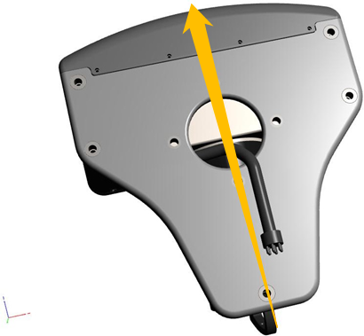

Figure 4.1 MS400P Acoustic Transducer

The direction indicated by the red arrow is the forward direction of sounding measurement. When installing the transducer, pay attention to its direction. The watertight cable is drawn from the center hole and passes through the connecting flange. Design the adapter flange and installation according to the actual situation of the surveying ship and the mechanical drawing of the acoustic transducer (See Appendix 1). Connect with the bracket to fix the acoustic transducer on the measuring boat or mounting pole.

# Sonar Interface Module Operation

## Sonar Interface Module Introduction

The Sonar Interface Module of MS400P is the data processing center of the multibeam echo sounding system, which mainly includes transducer interface, auxiliary device interface, communication interface and main control computer.

The appearance of sonar interface module is shown in Figure 5.1. See Appendix 2 for its mechanical drawing.

电子仪器

Figure 5.1 Sonar Interface Module

The main functions of the sonar interface module include the following aspects:

First, the main control computer software sends commands to the auxiliary devices’ information acquisition part and acoustic transducer through Ethernet interface;

Second, the sounding results and status of the acoustic transducer are transmitted to the data display and control computer through the Ethernet;

Third, auxiliary devices’ information acquisition module establishes a local time system according to the time information provided by GNSS, and sends other auxiliary devices’ information to the computer and acoustic transducer.

## Sonar Interface Module Connecters and Indicators

### Front Panel

The front panel of MS400P multibeam echo sounder consists of multiple indicator lights, as shown in the Figure 5.2 below.

The three indicators on the left represent PPS signal, synchronization signal and working status of the sound velocity sensor respectively. The three indicators on the right represent the GNSS differential signal, the attitude measurement equipment and the GNSS working status respectively.

Figure 5.2 Sonar Interface Module Front Panel

Below is the indicator status introduction.

|  |  |  |
| --- | --- | --- |
| **Indicator** | **Normal Status** | **Abnormal Status** |
| PPS | Blinks every 1s | Off or abnormal blinking rate |
| SYNC | Blinks at the rate of PING rate | Off or abnormal blinking rate |
| SVS | Blinks at the rate of sound velocity output rate, default is 8Hz | Off |
| MOTION | Blinks at the rate of attitude output rate, default is 100Hz | Off |
| DIF-MSG | Blinks at the rate of GNSS differential signal, default is 1Hz | Off |
| GNSS | Blinks at the rate of GNSS output rate, default is 1Hz | Off |

### Back Panel

The back panel of the sonar interface module is mainly composed of power module, Ethernet transmission interface, auxiliary device data interface, PPS interface, synchronization interface, GNSS antenna interface, sound velocity sensor interface and sonar watertight cable interface, as shown in the figure 5.3 and 5.4

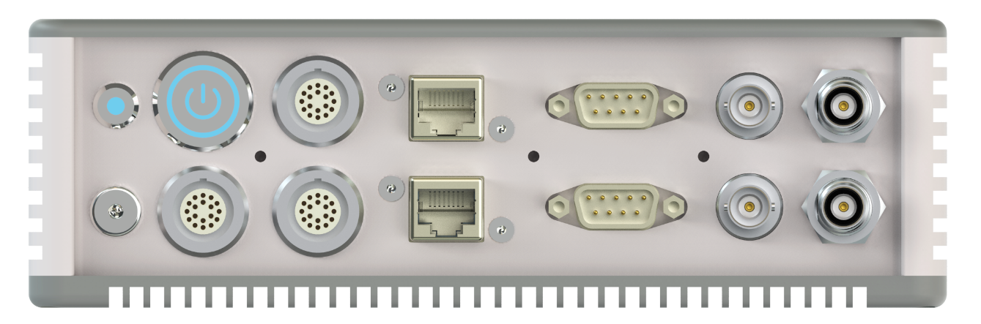

Figure 5.3 Sonar Interface Module Back Panel

Figure 5.4 Sonar Interface Module Back Panel

The exact usage of each interface is listed as below.

|  |  |
| --- | --- |
| **Interface** | **Function** |
| Status | Indicator of the device status |
| Earth | Connect the device with earth |
| On/Off | Power switch of the device |
| Power | Connect with DC or AC power supply |
| Data | Data input / output connector |
| Sonar | Connect with transducer |
| LAN1 | Ethernet port to connect with display and control or navigation PC |
| LAN2 | Ethernet port to connect with display and control or navigation PC |
| GNSS | Connect with external GNSS Receiver |
| SVS | Connect with sound velocity sensor SVS1500 for power supply and input sound velocity data |
| PPS | PPS signal input or output |
| SYNC | Synchronization signal input or output |
| SEC ANT | Connect with the front GNSS antenna for heading |
| PRI ANT | Connect with the primary GNSS antenna for position |

Among them, the data interface is for extending port. Below is the introduction of the indicator status and data extending port.

|  |  |
| --- | --- |
| **Connector** | **Status and Function Introduction** |
| Status Indicator | Red: Sonar Interface Module is not connected or mis-connected. |
| Yellow: The device is in preparation. |
| Green: The device is normal and ready to start up operation. |
| COM1 (GNSS COM) | External GNSS input, 9600 ~ 115200bps auto adaptive |
| COM2 (SVS COM) | Sound Velocity Sensor data input, the Pin 7 supports 12V power output, 9600 ~ 115200bps auto adaptive |
| COM3 (Extended data cable connecting out) | External RS232 data input, 9600 ~ 115200bps auto adaptive |
| COM4 (Extended data cable connecting out) | External RS232 data input, 9600 ~ 115200bps auto adaptive |
| COM5 (Extended data cable connecting out) | External RS232 data input, 9600 ~ 115200bps auto adaptive |
| COM6 (Extended data cable connecting out) | External RS232 data input, 9600 ~ 115200bps auto adaptive |

# System Installation and Configuration

MS400P series multibeam echo sounder consists of underwater acoustic transducer and sonar interface module. Below we will introduce the composition of the whole system and explain the system installation involving the underwater parts and the above-water units respectively.

The components of MS400P system are all packed in the carrying case. Figure 6.1 shows opening of the carrying case storing the main units and accessories.

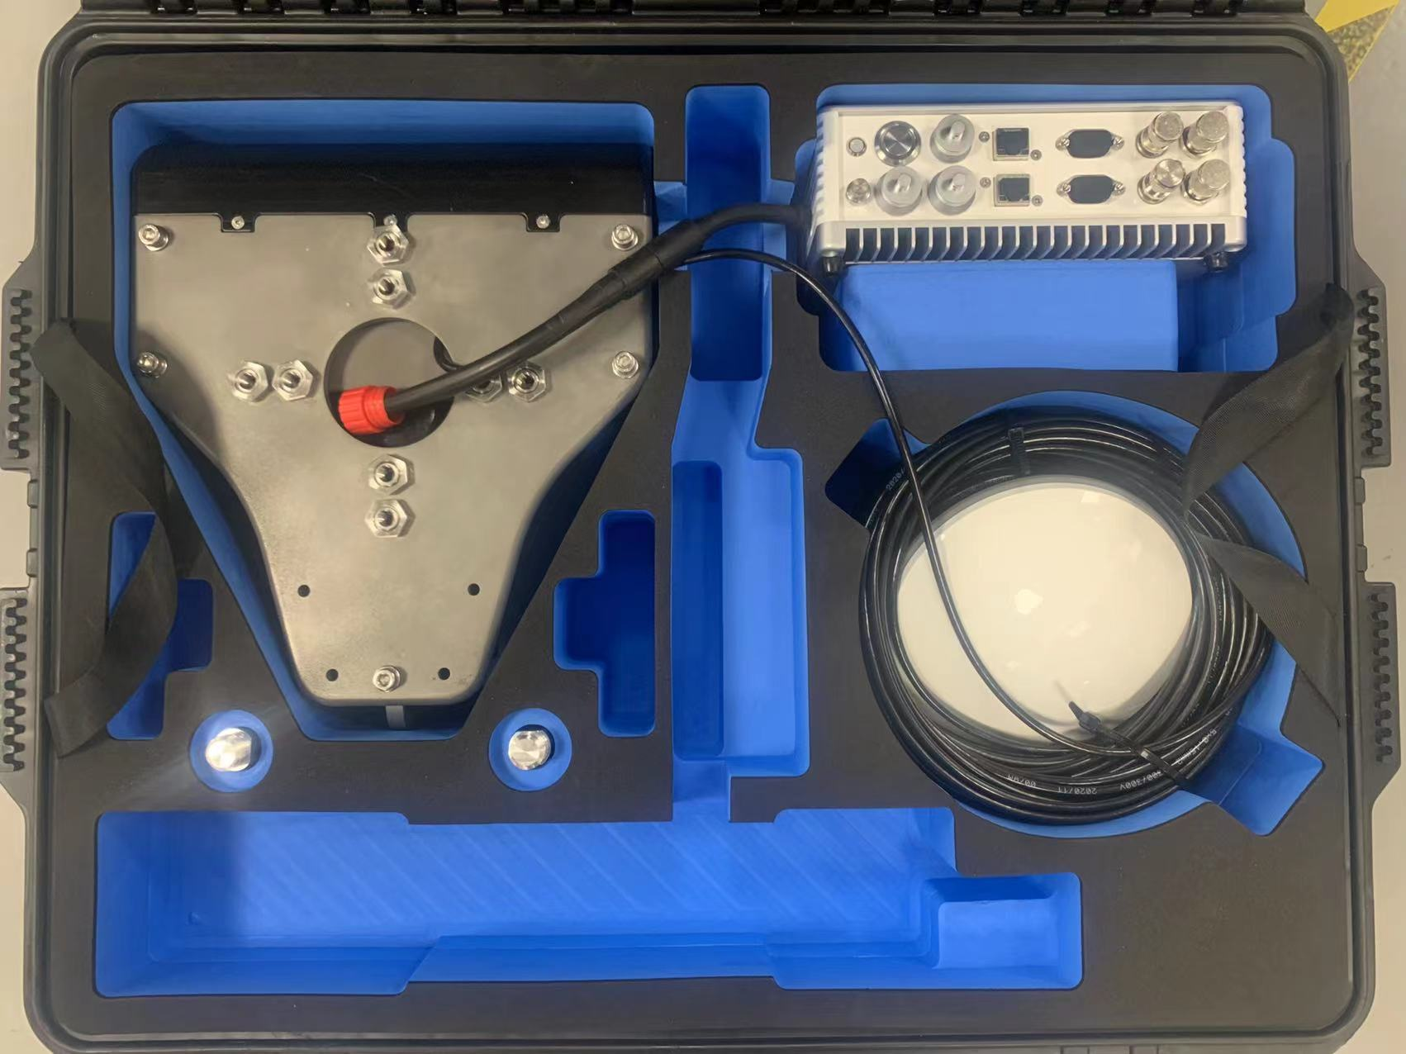

Figure 6.1 MS400P Multibeam Echo Sounder Carrying Case

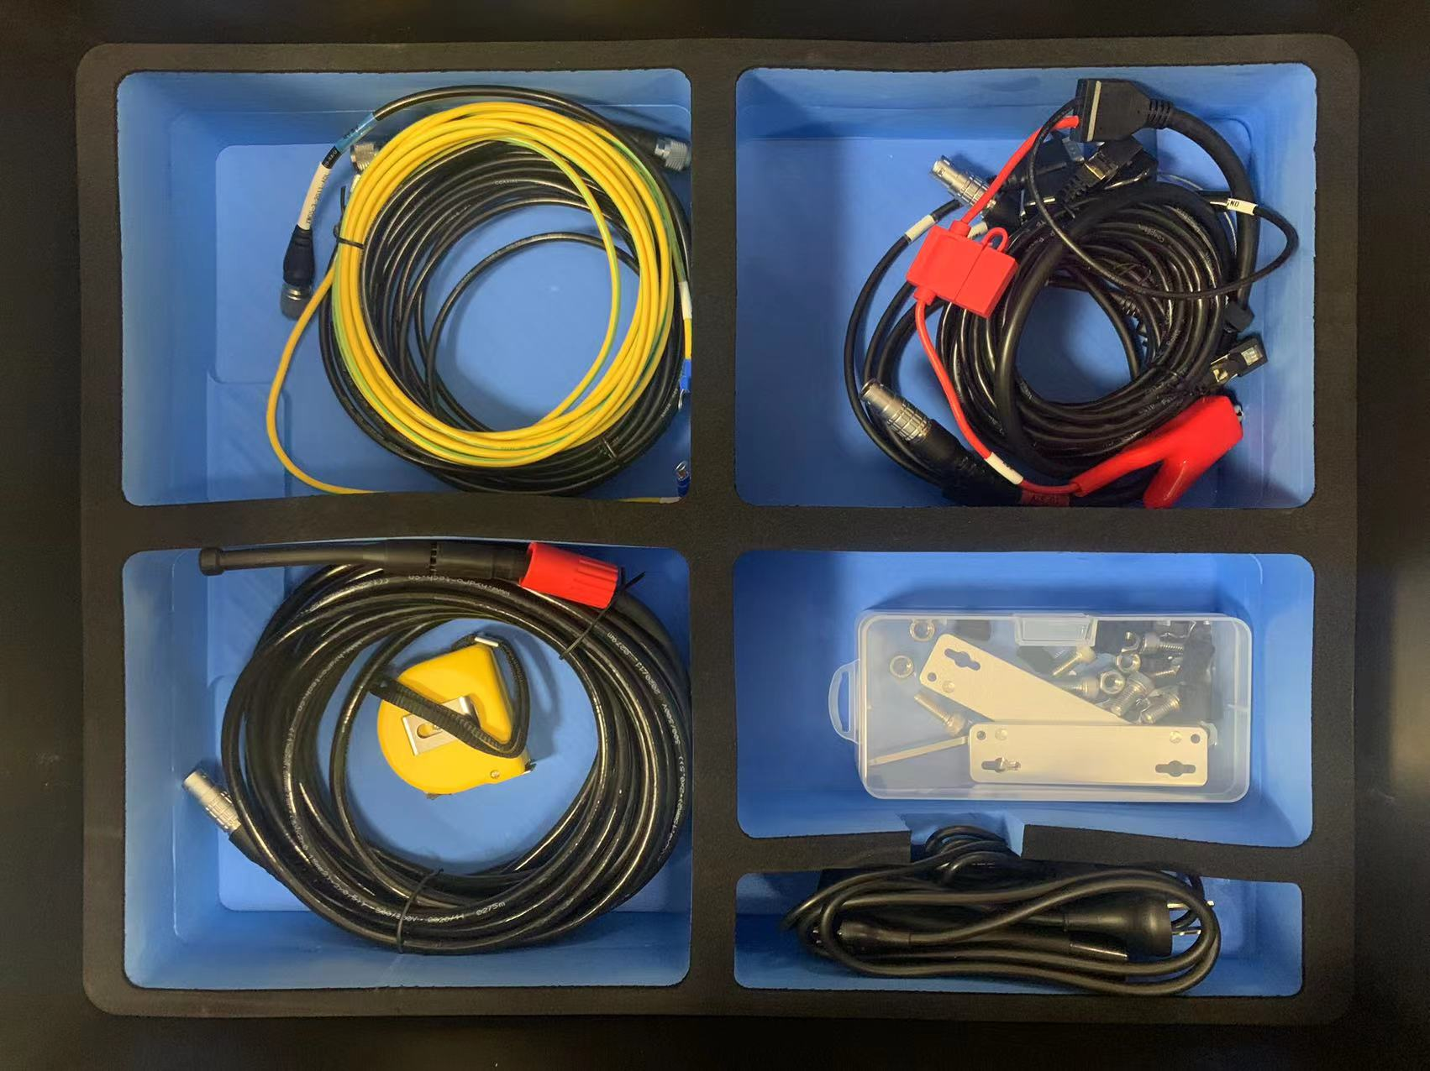

Figure 6.2 MS400P Multibeam Echo Sounder 2nd Layer in Carrying Case

## Underwater Parts Installation

Underwater parts include acoustic transducer, sound velocity sensor, SVS cable and flange mount, which have been assembled in factory. Users do not need to fix by themselves. The underwater parts look like Figure 6.3.

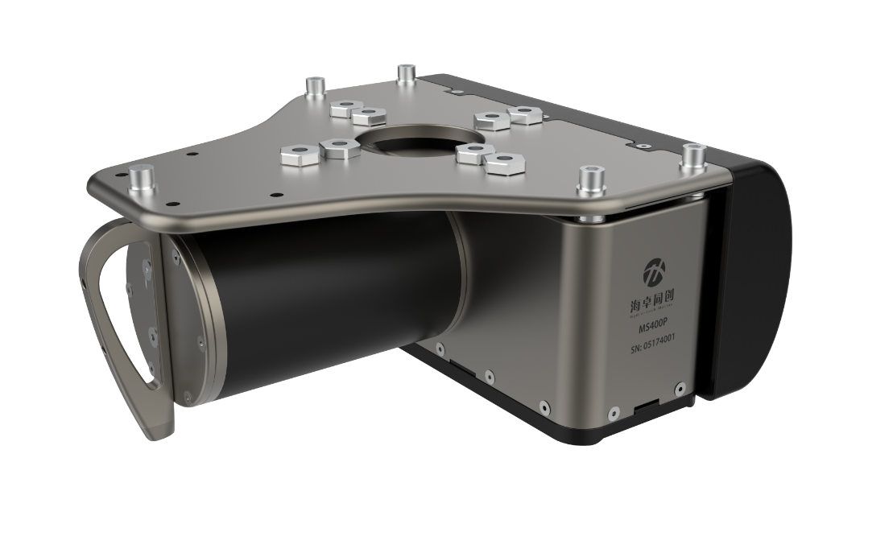

Figure 6.3 Underwater Transducer Unit

### Underwater Transducer Installation

Please follow the below steps to install the transducer safely.

(1) Pass the watertight cables of acoustic transducer and sound velocity senser through the steel pipe of the mounting bracket, and carry out the necessary anti-cut protection;

(2) Fix the underwater transducer with adapter flange;

(3) Connect and protect the transducer with steel cable or other strip;

(4) Fix the mounting bracket and acoustic transducer to the ship's aside;

(5) Tighten the steel cable or strip to prevent transducer and bracket vibration during the sounding measurement;

### Underwater Installation Precautions

(1) Select a suitable surveying vessel according to draft request & the hydrological conditions of the surveying water field and the size of the multibeam echo sounder;

(2) When choosing the installing location of the acoustic transducer, consider the safety of transducer, especially the impact of underwater obstacle, wharf & shallow beach and the influence of surrounding objects (Away from propeller, water outlet and select right installation depth to avoid vessel bottom shielding) on the measurement.

(3) During the installation process, correspondingly protect the surface of the transducer to prevent scratching by hard objects;

(4) It is not suitable for sounding operations in areas where the water is not deep enough to prevent damage to the transducer;

(5) It is not suitable for sounding operations when there are too many objects, such as twigs, fishing nets, in water to prevent damage to transducer;

(6) The underwater transducer installation shall ensure solid, avoid vibration, shaking, shock or deformation;

(7) For other precautions, please refer to the Part 3. Safety in this manual;

## Sonar Interface Module Installation

Sonar Interface Module need connect with underwater transducer, display & control computer and other accessories.

### Sonar Interface Module Introduction

1. **Sonar Interface Module:**

Its connectors are shown as Figure 6.4. For details, please refer to the Part 5. Instructions for use of deck unit in this manual.



Figure 6.4 Sonar Interface Module Back Panel

1. **GNSS antenna:**

Two GNSS antennas are used for attitude and heading measurement, they are as shown in Figure 6.5.

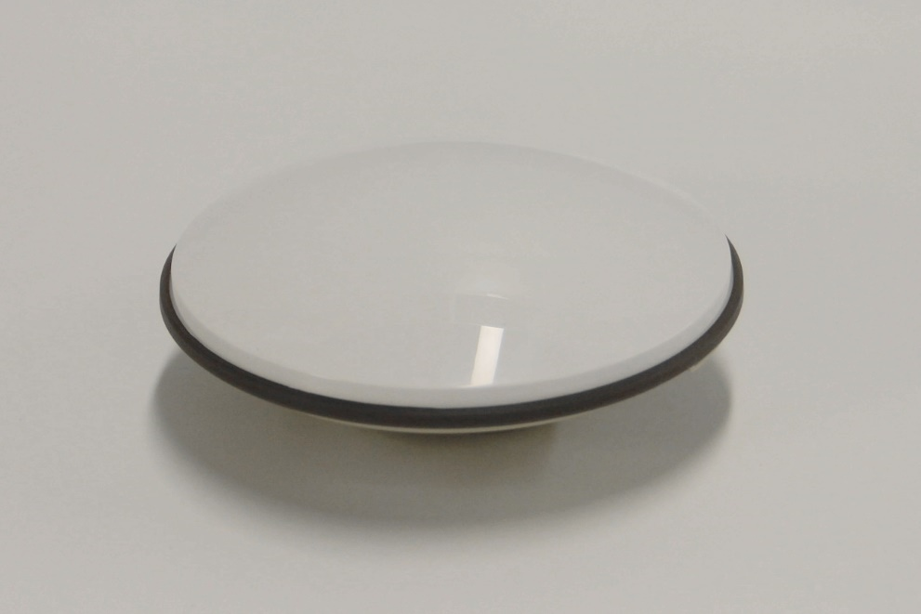

Figure 6.5 GNSS Positioning & Heading Antenna

GNSS antenna need install on magnetic mounting pole as shown in Figure 6.6.

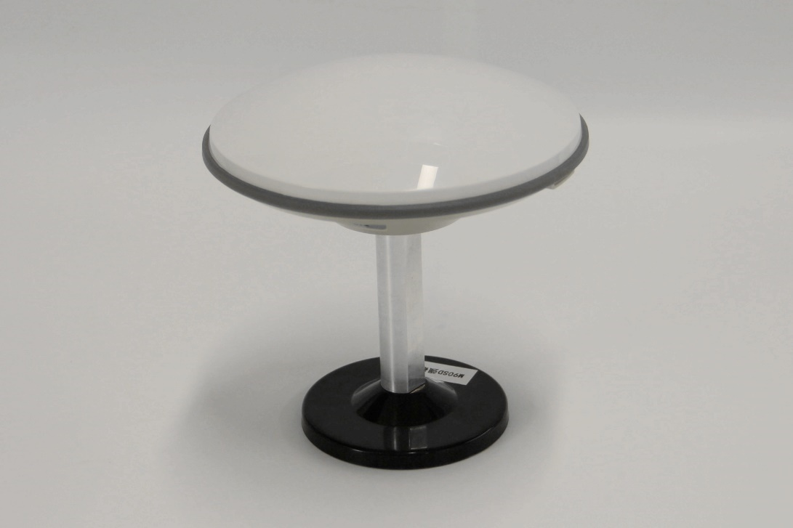

Figure 6.6 GNSS Antenna and Magnetic Mounting Pole

1. **Display and Control Computer:**

It is used to display the sounding result, control echo sounder working modes, data acquisition and navigation as shown in Figure 6.7.

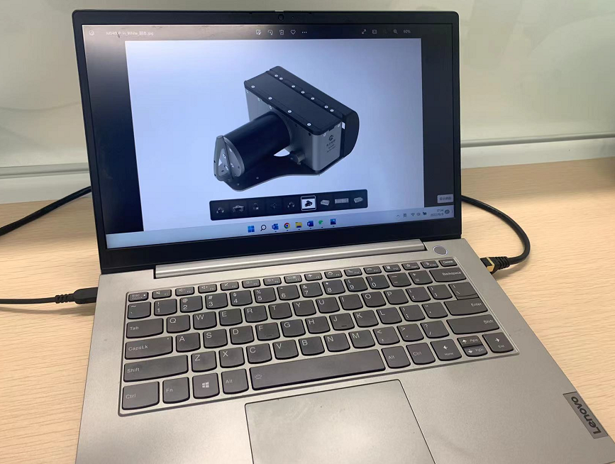

Figure 6.7 Display & Control Computer

1. **GNSS Antenna cable:**

It is used to connect GNSS antenna and Sonar Interface Module as shown in Figure 6.8.

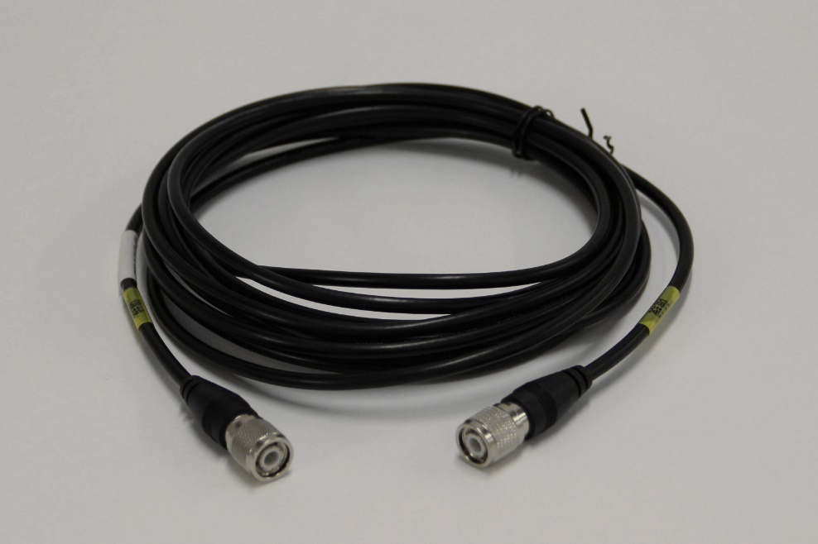

Figure 6.8 GNSS Antenna Cable

1. **Power Cable:**

It is used to connect sonar interface module with power supply, including DC and AC power cables, as shown in the Figure 6.9 is 220V AC power cable and Figure 6.10 is 24V DC power cable.

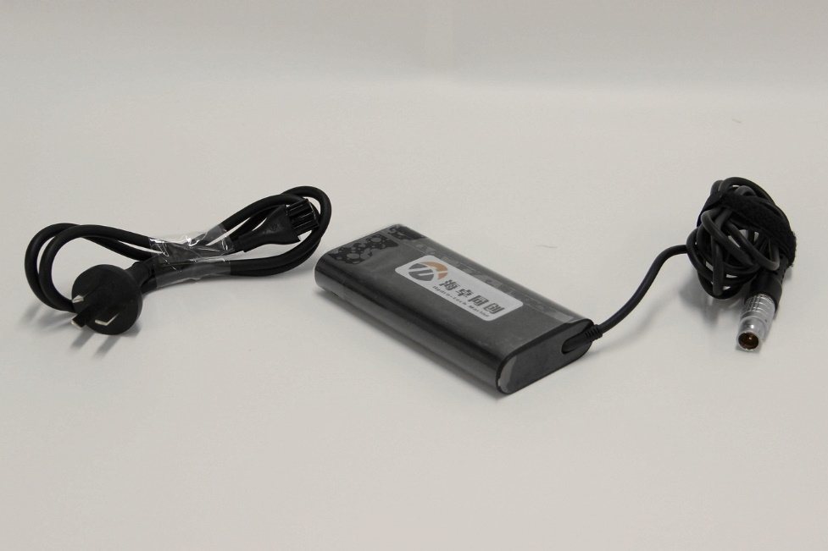

Figure 6.9 220V AC Power Cable

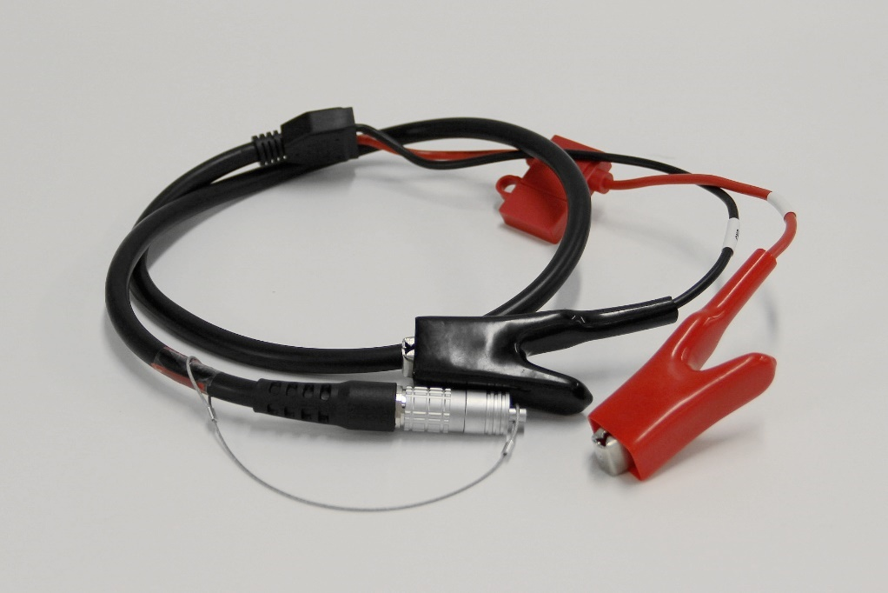

Figure 6.10 24V DC Power Cable

1. **Type 7 Dual Shielding Ethernet Cable:**

Used to connect Sonar Interface Module with display & control PC, which is same as show in Figure 6.11.

Figure 6.11 Type 7 Dual Shielding Ethernet Cable

### Sonar Interface Module Installation

(1) Fix the sonar interface module and display & control computer in a suitable area of the cabin to prevent slipping or dropping during operation;

(2) Connect the watertight cables of underwater transducer and sound velocity sensor to the corresponding connectors of sonar interface module;

(3) Use the DC or AC power supply, plug the power cable into the corresponding connector of sonar interface module;

(4) Use the Ethernet cable to connect the sonar interface module and display & control computer;

Note: For the corresponding connector information, please refer to Part 5.2.2 Back Panel.

# How to set up RTK?

1. MS400P Sonar Interface Module (Hereafter refer to SIM) connect to power supply. The LAN port connect to PC computer. At the same time, transducer is also installed underwater and connected to SIM. Then power on the power supply.
2. Open HydroQuest to check whether the underwater parts and the other devices on the deck is well connected. If yes, the 2 icons at the right bottom of the software will show green light (Some time, if computer is set up 2 IP address or with not only network card, it will show red, but everything still work normal).

If not connect well, power off the power supply first. Double check the hardware and network connection, make sure everything is connected correctly, then power on again.

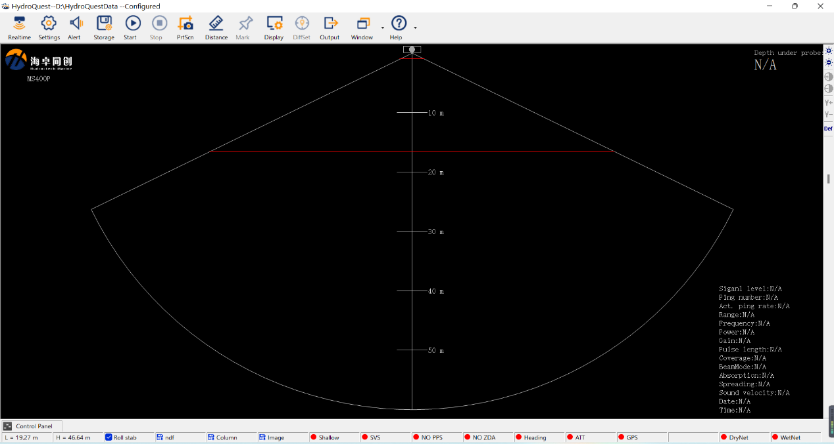

1. Use NTRIPClient to set up the COM port and internet RTK parameters. If needed, please refer to NTRIPClient Manual for details.
2. Install the software of USR-VCOM_V3.7.1.520_Setup.exe, which is a virtual COM port software.
3. Open USR-VCOM to set up virtual COM port, the process is as below:

Click the left button of “Add” to set up virtual COM port.

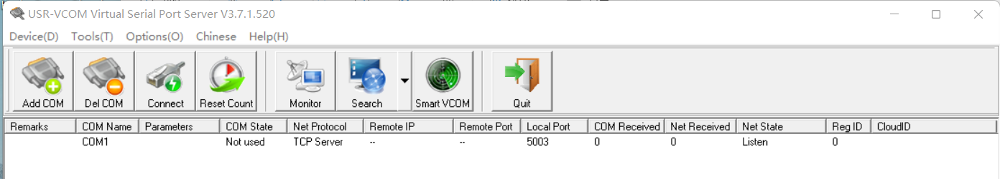

**The first line is to set up Virtual COM port No., which must be the same with COM port set in Ntrip.**

Second line is to set up the network protocol as TCP Server.

Both of the third line of local IP address and forth line of target port are no need to set up.

The fifth line is local port, which shall be set up as 5003.

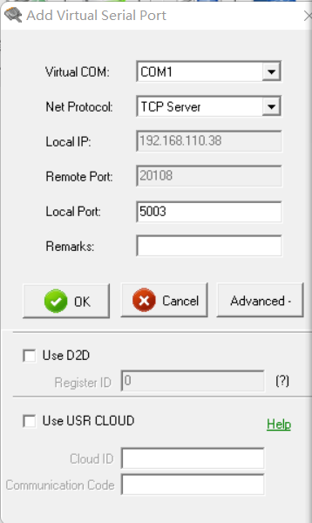

After finished, click the left button of OK. And the screen change to below.

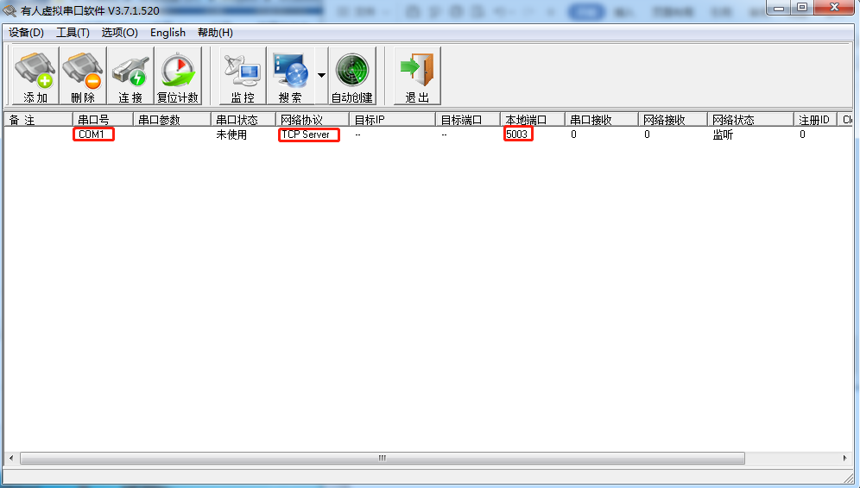

1. Then set up the COM for RTCM in Port Setting in HydroQuest as shown below.

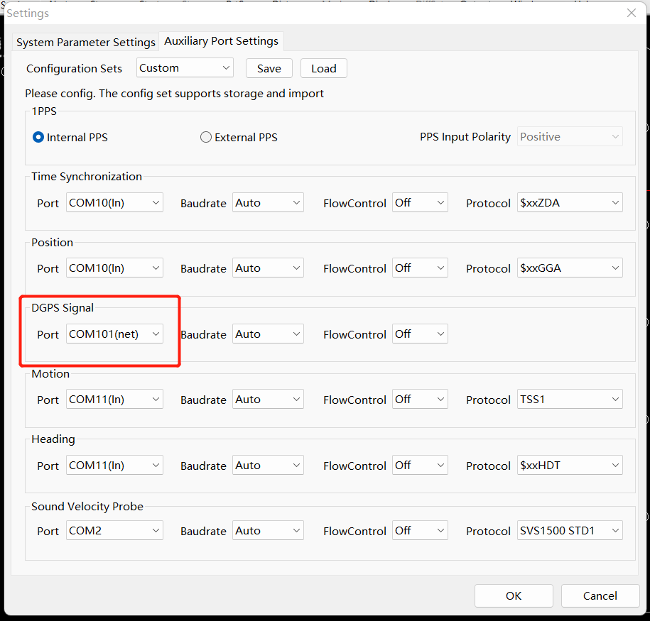

1. Then check the bottom in HydroQuest to see the GPS Status. If where the arrow pointed at turns to be GPS Fix, it means the setting is successful and RTK works well.

If abnormal, check the setting up and repeat step 1 to 6.

## How to use NTRIPClient

Double click “NTRIPClient.exe” to run NTRIP.

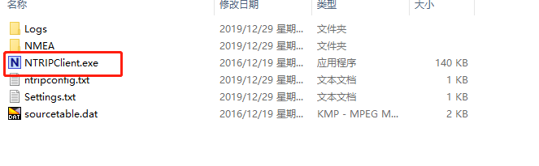

## COM Port Setting

This is to set up the COM port to receive RTCM message, click “EDIT”

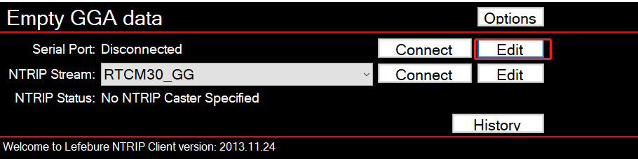

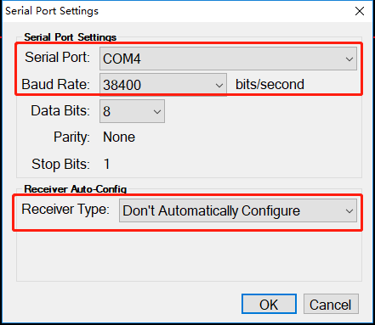

Set “Serial Port” and “Baud Rate”. The default baud rate of MS400P RTCM setting is 38400.

Click the button of “Connect” to connect the port.

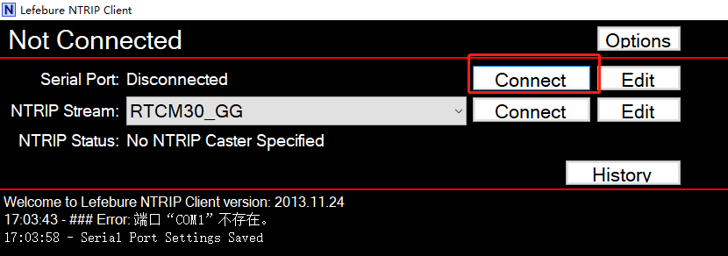

Then the screen will change to the figure shown as below.

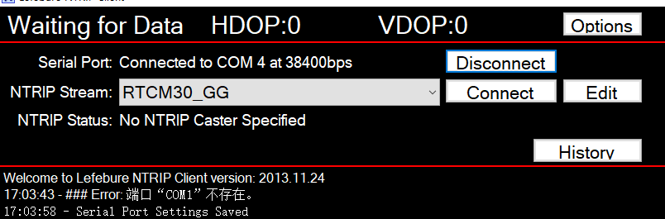

## NTRIP Setting

Click the list after “NTRIP Stream” and select RTCM30_GG.

Please be noticed that MS400P Internal GNSS board does not support V32. So not choose V32, but choose V30, which is RTCM30.

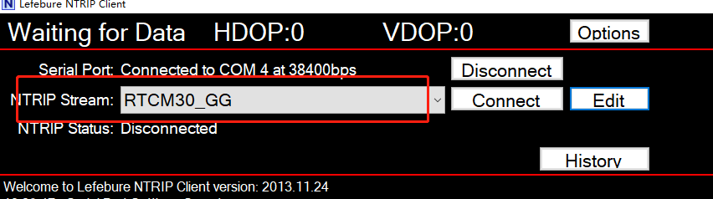

Account Setting

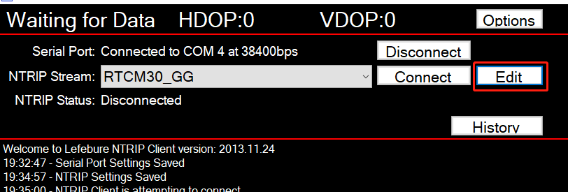

After click “Edit”, then enter server setting.

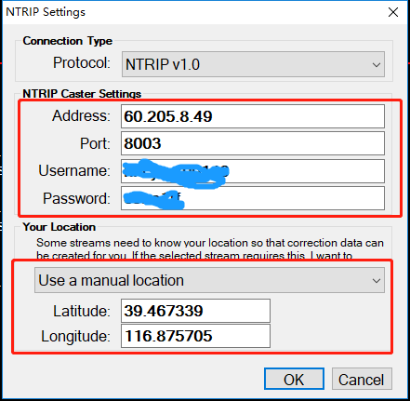

Input the IP address, port, username and password.

At the location field, input the latitude and longitude in degree. Then click OK and connect to NTRIP Server:

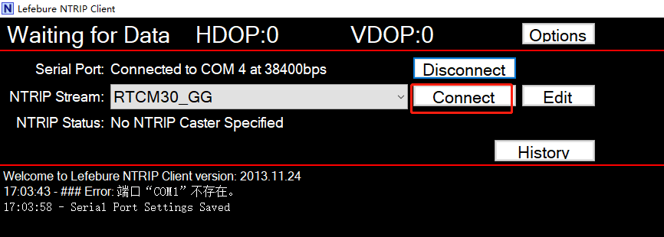

Click button of “Connect” to finish the server connection work.

If setting up correctly, NTRIP Status will show “Connected, followed with the data size received”.

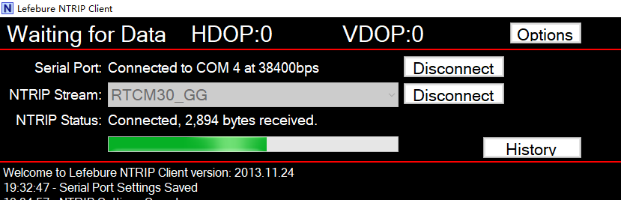

## Check the Internal GPS Status

With COM port cable connecting with COM4 of MS400P Sonar Interface Module (SIM or called Deck Unit), check the positioning status of internal GNSS board from HydroNavi.

# Appendix 1 Underwater Transducer Drawing

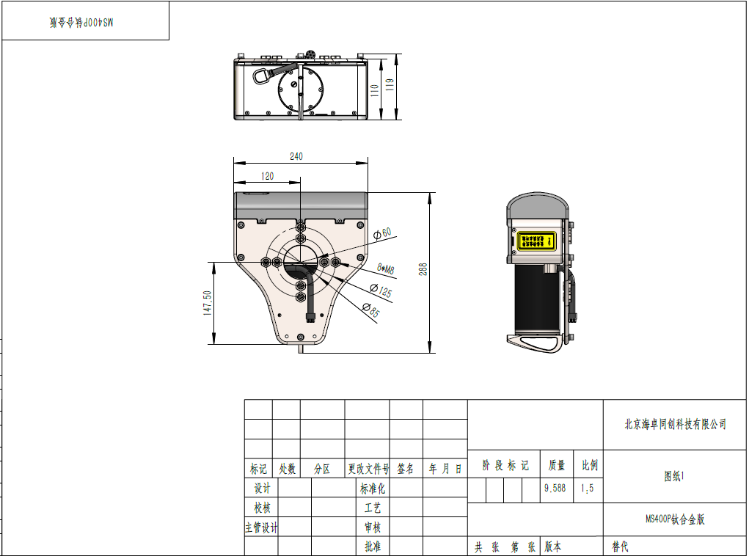

# Appendix 2 Transducer & IMU Center Drawing

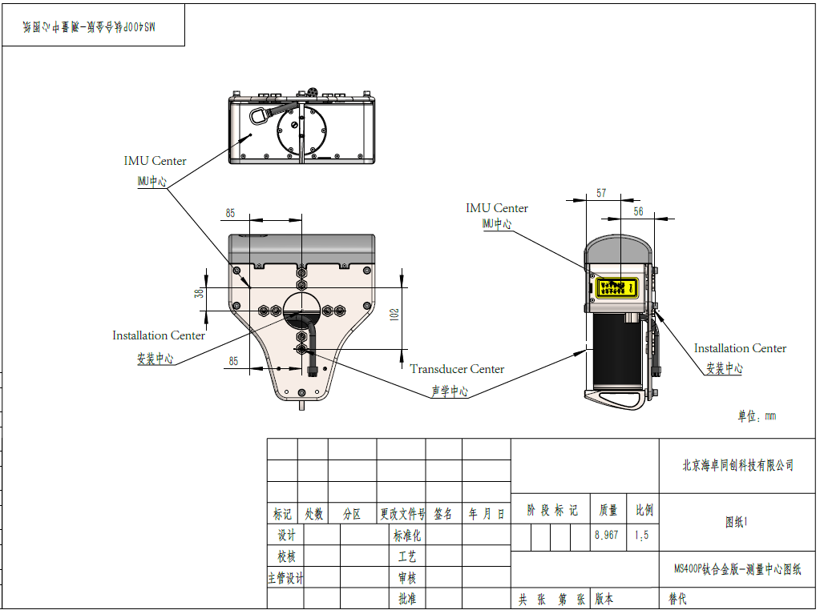

# Appendix 3 Sonar Interface Module (Deck Unit) Drawing

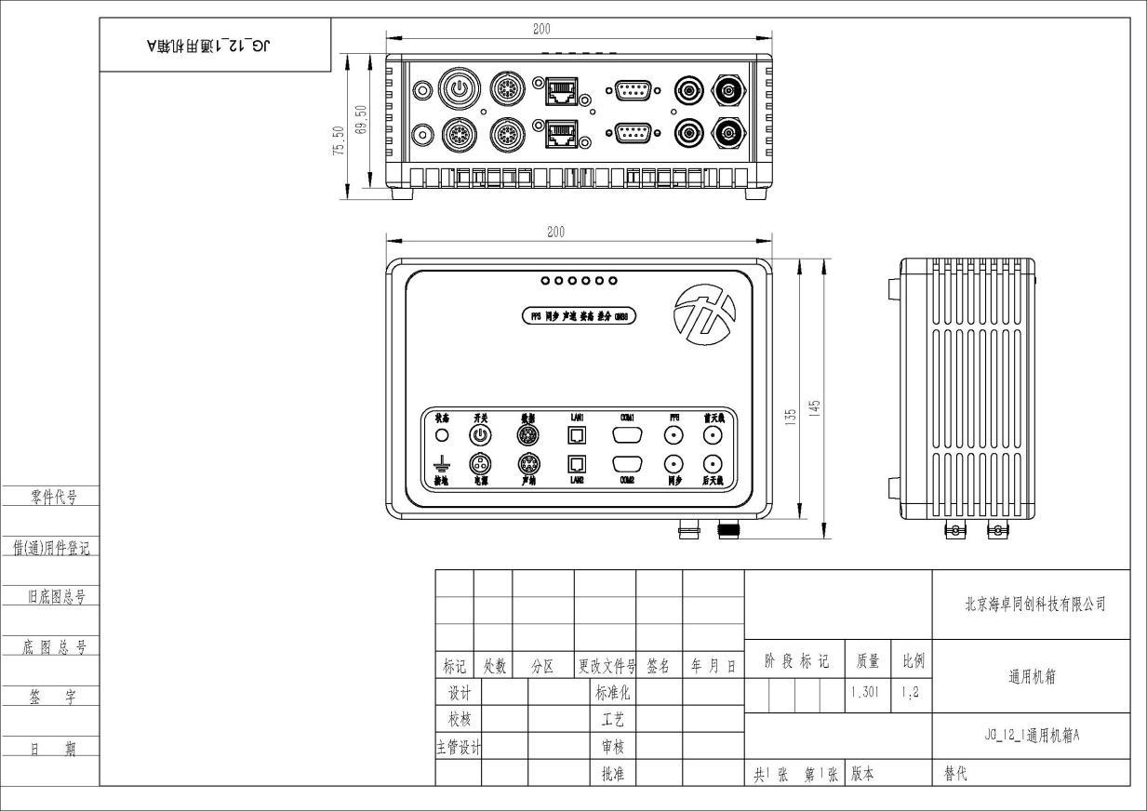

# Appendix 4 Wet Cable Definition

|  |  |  |  |  |
| --- | --- | --- | --- | --- |
| **A End** | **Q’ty** | **Cable Length / Cable Specification** | **B End** | **Q’ty** |
| MCIL8F (Connector Tail 20 ± 2cm) | 1 | 8m / 10-core BASF cable | FGG.2B.310.CLAD82 | 1 |
| **Pin** | **Color** | **Waterproof Core Color** | **Pin** | **Signal** |
| 1 | Black | Thick Black | 1 | GND |
| Thick Blue | Empty |
| 2 | White | Thick Red | 2 | VCC |
| Thick Brown | Empty |
| 3 | Red | Red White | 3 | ETH TX- |
| 4 | Green | Thin Red | 4 | ETH TX+ |
| 5 | Orange | Green White | 5 | ETH RX- |
| 6 | Blue | Thin Green | 6 | ETH RX+ |
| 7 | Yellow / Grey | Blue White | 7 | RS485B |
| 8 | Brown- | Thin Blue | 8 | RS485A |
|  | Shielding |  | 9 | Shielding GND |
|  |  |  | 10 (Empty) |  |

Remarks：

1. B End need to be vulcanized after welding;
2. After A End is welded, it is necessary to apply thread glue, when twisting the tail clip, and encapsulate it for waterproof.